

Assignment

Name M.Asbah Khan

Roll No BCS-F24-E01

Teacher Sir.Raza

Semester 5th

Subject Operating System

Department Computer Science

University of Mianwali

Task 1:
Write a program that takes a user’s name directly from the terminal command used to run the program, and prints a greeting.
Code :
#include<iostream>
#include<string>
using namespace std;

int main() {
string name;
cout << "Enter your name: ";
getline(cin, name);
cout << "Hello, " << name << "!" << endl;
return 0;
}

Resulting Output :
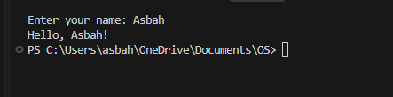

Task 2:
Write a program that creates a text file, writes "Hello OS" into it, and then closes it.
Code :
#include<iostream>
#include<fstream>
using namespace std;

int main() {
fstream file;
file.open("name.txt", ios::out);
string name = "John Doe";
file << "Hello, " << name << "!" << endl;
file.close();
return 0;
}

Resulting Output :
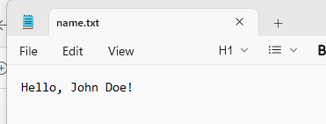

Task 3:
Write a program that prints its own unique ID number to the screen.
Code :
#include <iostream>
#include <windows.h>
using namespace std;

int main() {
cout << "My unique Process ID is: " << GetCurrentProcessId() << endl;
return 0;
}

Resulting Output :
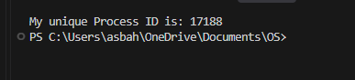

Task 4:
Write a program that prints "Going to sleep...", waits for 3 seconds, and then prints "Waking up!".
Code :
#include <iostream>
#include <windows.h>
using namespace std;

int main() {
cout << "Going to sleep...\n";
Sleep(5000); // Sleep for 5 seconds
cout << "Awake!\n";
return 0;
}

Resulting Output :


Task 5:
Write a C program that tells the terminal to list all the files in the current folder (like running dir on Windows or ls on Mac/Linux).
Code :
#include <stdio.h>
#include <stdlib.h>

int main() {
system("dir");
return 0;
}

Resulting Output :
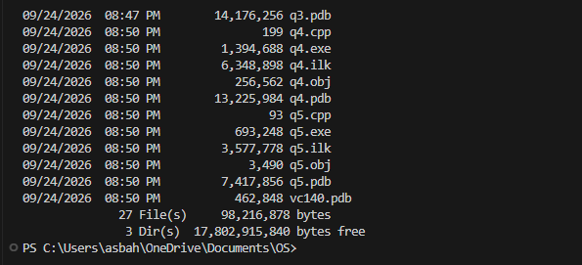

Task 6:
Write a program that finds and prints the username of the person currently logged into the computer.
Code :
#include <iostream>
#include <stdlib.h>
using namespace std;

int main() {
cout << "Current user is: " << getenv("USERNAME") << endl;
return 0;
}

Resulting Output :
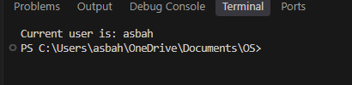

Task 7:
Try to open a file that doesn't exist, and instead of crashing, print the exact error message the system gives you.
Code :
#include <stdio.h>

int main() {
FILE *file;

file = fopen("does_not_exist.txt", "r");

if (file == NULL) {
perror("Error opening file");
return 1;
}

fclose(file);
return 0;
}

Resulting Output :
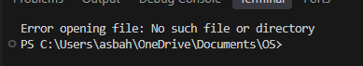

Task 8:
Write a program with an infinite "You can't close me!" if the user presses while loop that prints a message every second, but prints Ctrl+C instead of exiting.
Code :
#include<iostream>
#include<string>
using namespace std;

int main() {
string name;
cout << "Enter your name: ";
getline(cin, name);
cout << "Hello, " << name << "!" << endl;
return 0;
}
Resulting Output :
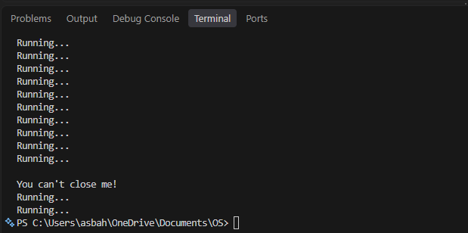

Task 9:
Write a program that clones itself into two identical programs running at the same time, using an if-else statement to have one print "I am the parent" and the other print "I am the child".
Code :
#include <stdio.h>
#include <unistd.h>

int main() {
int pid = fork();

if (pid == 0) {
printf("I am the child\n");
}
else if (pid > 0) {
printf("I am the parent\n");
}
else {
printf("Fork failed\n");
}

return 0;
}

Resulting Output :

Task 10:
Build on the "Cloner" task. Make the child process sleep for 2 seconds, and force the parent process to wait until the child is completely finished before the parent prints "All done!" and exits.
Code :
#include <stdio.h>
#include <unistd.h>
#include <sys/wait.h>

int main() {
int pid = fork();

if (pid < 0) {
printf("Fork failed!\n");
}
else if (pid == 0) {
// Child process
printf("I am the child\n");
sleep(2);
printf("Child is finished\n");
}
else {
// Parent process
printf("I am the parent\n");
wait(NULL);
printf("All done!\n");
}

return 0;
}

Resulting Output :

